The Investigation of Land Surface Temperature and Vegetation In Big Cities of Indonesia

Rika Hernawati and Soni Darmawan

Institut Teknologi Nasional Bandung
Corresponding author: Soni Darmawan, soni_darmawan@itenas.ac.id

ABSTRACT
This study adopted remote sensing techniques to analyze the relationship between land surface temperature and vegetation density in a rapidly urbanizing tropical city of Medan, Bandung, and Makasar. The study aims to investigate the spatiotemporal variation of Land Surface Temperature (LST) and Normalized vegetation index (NDVI) for Medan, Bandung, and Makassar; and analysis of LST–NDVI relationship. The Spatio-temporal of NDVI and LST were retrieved from the Landsat dataset in 1990, 1995, 2000, 2005, 2010, 2015, and 2019. All satellite images were geometrically and radiometrically corrected, and the mono-window algorithm was used to generate the LST using the thermal band, and the near-infrared and red band were calculated for NDVI. The mean of LST and NDVI values were associated with correlation using regression linear. The results showed that the distribution and Spatio-temporal of NDVI and LST over the 29 years have a drastic decrease for NDVI and increased for LST. Moreover, NDVI and LST's relation has a strong negative relationship with correlation coefficient (R²) values of 0.98 in Medan, 0.80 in Bandung, and 0.70 in Makassar. This value indicated the excess of NDVI and LST have a significant inverse correlation, where increasing the NDVI value, the LST value will tend to decrease.
Keywords: LST, NDVI, Correlation, Landsat, Urban.

INTRODUCTION
All big cities worldwide continue to grow in both population and physical size. More significant consideration of how rural lands are developed for urban and suburban land use will become more critical (Yue et al. 2014). In line with the increasing development of urbanization, the challenges of sustainable development in Indonesia are increasingly concentrated in big cities because people prefer to live in urban areas than in rural areas. The urban air temperature is continuously increasing in all cities in the world. One of the potential causes is the extreme decrease in cities' greenery area (Kumar and Shekhar 2015). Unplanned changes in land use in the study area have become a severe problem, and most of the land-use changes are carried out without planning and scant attention to environmental impacts (Fathizad et al. 2017).
Fast urbanization rapidly changes the characteristics of the surface components (Guha, Govil, and Diwan 2020). In further research, other researchers found that soil surface temperature (LST) and energy balance can be affected by vegetation(Kumar and Shekhar 2015) and is an essential factor in the physics of surface-to-ground processes, which combine the surface-atmosphere interactions and the heat flux between the atmosphere and the ground (Islam and Ma 2018). The most commonly used vegetation index is the normalized difference vegetation index (NDVI), which applies in LST computation (Guha, Govil, and Diwan 2020)(Smith and Choudhury 1990)(Hope and McDowell 1992). NDVI is an excellent index for identifying various vegetation cover and another (Fathizad et al. 2017). Change in vegetation is the main causes of land surface temperature differences related to vegetation density (Fathizad et al. 2017).
Recently research has been conducted to find the relationship between NDVI and LST, such as Smith & Choudhury (1990) (Smith and Choudhury 1990); Hope & McDowell (1992) (Hope and McDowell 1992); Weng et al. (2004) (Weng, Lu, and Schubring 2004); Kim et al. (2005) (Kim, Kim, and You 2005); Yue et al. (2007; 2014) (Yue et al. 2007) (Yue et al. 2014); Kumar & Shekar (2015) (Kumar and Shekhar 2015); Anbazhagan & Paramasivam (2016) (S. and C.R. 2016); Fathizad et al. (2017) (Fathizad et al. 2017); Tariq et al. (2020)(Tariq et al. 2020); Guha & Govil (2020) (Guha and Govil 2020).
Some recent research works based on the spatial-temporal relationship of LST–NDVI in Indonesia big cities have also been performed successfully, such as in Medan Rahmad et al. (2019) (Rahmad, Nurman, and Pinem 2019), in Bandung Wardana (2015)(Wardana 2015); Ningrum & Narulita (2018)(Ningrum and Narulita 2018); Simanjuntak, (2017)(Simanjuntak 2017), and in Makasar Muzaky & Jaelani (2019)(Muzaky and Jaelani 2019). It is necessary to compare the time series of LST–NDVI relationships in a different city, which is still a little bit discussed in previous studies.
The aims of this study are (1) to investigate the spatiotemporal variation of LST and NDVI for Medan, Bandung, and Makassar; and (2) to the analysis of LST–NDVI relationship. LST and NDVI were determined from various types of Landsat sensor products for 1990, 1995, 2000, 2005, 2010, 2015, and 2019 as the landscape changed a lot during this time frame. To analyze the LST's spatiotemporal dynamics was computed using the Statistical Mono-Window (SMW) algorithm, and NDVI was derived from Landsat using a near-infrared band and red band.

Material and methods

Study Area
To determine the characteristics of the spatiotemporal variation of LST–NDVI relationship in a different city, we selected Medan, Bandung, and Makassar City. The cities are an excellent example of a varied landscape.

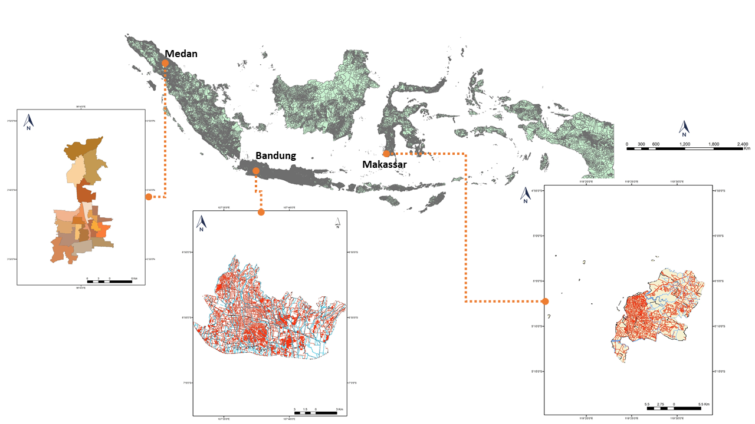
Figure 1. Study Area in Medan, Bandung, and Makassar

Methodology
The methodology used in this study includes data sources, geometric corrections, and radiometric corrections, which are the preprocessing steps required for Landsat images, and processing includes surface temperature (LST) collection, NDVI assessment, and determination of the relationship between NDVI and LST

Data Source
The data was extracted from Landsat-4, Landsat-5, Landsat-7, and Landsat-8 images acquisition collected from 1990, 1995, 2000, 2005, 2010, 2015, 2019 showed in Table 1 and ancillary data from topographic maps Medan, Bandung, and Makasar City. The images were obtained from the US Geological Survey (USGS) Landsat series of Earth Observation satellites. All images were in a geographic latitude/longitude projection and datum World Geodetic System 1984 (WGS84).
Table 1. Acquisition Landsat data
Date of acquisition | Satellite Sensor | Time | Path/Row
Bandung
10 August 1990 | Landsat 5 | 02:20:28.089 | 122/65
11 October 1995 | Landsat 5 | 02:01:05.541 | 122/65
01 May 2000 | Landsat 5 | 02:35:54.10 | 122/65
07 May 2005 | Landsat 7 | 02:50:05.665 | 122/65
21 May2010 | Landsat 7 | 02:52:35.483 | 122/65
27 May 2015 | Landsat 8 | 02:59:33.344 | 122/65
22 May 2019 | Landsat 8 | 03:00:07.622 | 122/65
Makassar
16 August 1990 | Landsat 4 | 01:35:50.182 | 114/064
13 June 1995 | Landsat 5 | 01:16:55.831 | 114/064
12 Jule 2000 | Landsat 5 | 01:47:36.345 | 114/064
02 September2010 | Landsat 7 | 02:02:55.29 | 114/064
06 July 2015 | Landsat 8 | 02:10:06.187 | 114/064
21-October-2019 | Landsat 8 | 02:11:02.536 | 114/064
Medan
29 January 1995 | Landsat 5 | 02:52:36.831 | 129/057
12 December2000 | Landsat 5 | 03:19:54.442 | 129/057
25 Febuary 2005 | Landsat 5 | 03:27:17.177 | 129/057
15 February 2010 | Landsat 7 | 03:32:28.246 | 129/057
21 February 2015 | Landsat 8 | 03:40:22.264 | 129/057
11 August 2019 | Landsat 8 | 03:40:40.350 | 129/057

Pre-Processing
A larger dataset might ensure adequate representation of The LST from Landsat 4, 5, and 7. Briefly, the radiance values derived were used to calculate at satellite brightness temperature, that is, black body temperature followed by a correction for spectral emissivity according to the landscape (Weng, Lu, and Schubring 2004). LST distribution with band 6 (Landsat-5 and 7), band 10 (Landsat 8), and top of atmosphere brightness temperature values have been represented in Kelvin for each of the study areas (Tariq et al. 2020).
The digital numbers (DN) of TIRS and OLI bands were converted to spectral radiance and top of atmosphere (TOA) planetary reflectance to preprocess the satellite images. The formula to convert DN to radiance below was used (Landsat 8 (L8) Data Users Handbook, 2019):
L_{λ} = M_{L} Qcal + A9_{L} | (1)
Where L_{λ} = ToA spectral radiance, ML = band-specific multiplicative rescaling factor from the metadata, Qcal = quantized and calibrated standard product pixel values (DN), and AL = band- specific additive rescaling factor from the metadata.
The NDVI is computed by TOA planetary spectral reflectance, with solar angle correction. The DNs are converted to TOA planetary reflectance by the below equation (“Landsat 8 (L8) Data Users Handbook” 2019):
ρλ = ´ρλ/ sin θ = (Mp ∗ Qcal +Ap)/ sin θ | (2)
where ρλ and ´ρλ are TOA planetary spectral reflectance with and without solar angle correction (unitless), Mp is reflectance multiplicative scaling factor, Ap is reflectance additive scaling factor, and θ is solar elevation angle. ML, AL, Mp, Ap, and θ parameters in Equations is extracted from the metadata file, which is downloaded with satellite images from the USGS EarthExplorer.

NDVI Calculation
After conversion of the DN to reflectance, the normalized difference vegetation index (NDVI) forthe red and near infrared (NIR) bands was calculated by the following equation (Tucker 1979):

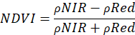 | (3)
The index is used based on the rationale that vegetation reacts to the absorption and reflection of red and near-infrared lights. NDVI values range from − 1 to 1. A value of zero indicates the presence of urban areas while a negative value is an indication of a water body. A positive value closer to one indicates the presence of green cover (Sahana et al. 2016; Tan et al. 2010; Babalola and Akinsanola 2016) (Mukherjee and Singh 2020).

LST Calculation
In this research, the mono-window algorithm has been applied to retrieve LST from multi-temporal Landsat satellite imagery (Guha, Govil, and Diwan 2020)(Qin, Karnieli, and Berliner 2001). Ground emissivity, atmospheric transmittance, and sufficient mean atmospheric temperature these three parameters are needed to determine the LST using a mono-window algorithm. After the extraction process in (1) equation, conversion of spectral radiance (L_{λ} ) to brightness temperatures (TB) corrections according to the following equation:
T_{B}= 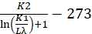 | (4)
where T_{B} is brightness temperature (°C), K1 and K2 stand for the band-specific thermal conversion constant from the metadata, Lλ is top of atmospheric spectral radiance. For the Conversion of sensor temperature to celsius, the absolute zero value was added to radiant temperature (Xu and Chen 2004).
The absolute temperature or Land surface temperature (LST) was estimated from average brightness temperature acquired from band 10 & band 11 of the Landsat 8 TIRS data, the wavelength of emitted radiance, land surface emissivity, and constant value P. Land surface emissivity was calculated from the vegetation fraction which, in turn, derived from NDVI value range. The absolute temperature was calculated according to the method as employed by (Latif and Kamsan 2017), while the Landsat visible and near-infrared bands were used for calculating the NDVI.
The vegetation index ( Pv ) was calculated according to the equation as described by (Carlson and Ripley 1997):
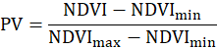 | (5)
Here NDVI_{min} represents minimum NDVI value indicating the presence of bare soil and NDVI_{max} is maximum NDVI value indicating the presence of healthy vegetation (Guha, Govil, and Diwan 2020).
While the Ground Emissivity (ε) and Emissivity-corrected values were calculated according to the following equations (Pal and Ziaul 2017).
ε = 0.985Pv + 0.960 (1-Pv) + 0.06Pv (1-Pv) | (6)
The emissivity corrected land surface temperatures (LST) was computed as following (OS and AA 2016)
LST = 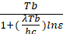 | (7)
Where Tb is Temperature Brightness (ºC), λ is wavelength of emitted radiance, ε is estimated land surface emissivity. Where ρ is the constant value obtained from Boltzman equation:
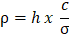 | (7)
where, h is Planck’s constant (6.26 x 10⁻³⁴Jsec), c is Light velocity (2.998 x 10⁸ m s⁻¹), σ is Stefan-Boltzman constant (1.38 x 10⁻²³ J K⁻¹).

RESULTS AND DISCUSSION
The study's primary objective is to determine the correlation of land surface temperature and vegetation index variables using multi-temporal Landsat data. The LST and NDVI obtained for 1990, 1995, 2000, 2005, 2010, 2015, and 2019 in Medan, Bandung, and Makassar. The NDVI indices were divided into 5 (five) classes using the density slicing method (Sari, Gun, and Hudman 2005) specifically, the non-vegetation indices class marked with pink color (NDVI ≤ 0.11), the deficient green indices class (VGI) marked with a peach color (0.11 ≤ NDVI ≤ 0.25), the low VGI class marked by the color dark green (0.25 ≤ NDVI ≤ 0.33), medium VGI grade indicated by light green (0.33 ≤ NDVI ≤0.45), and high VGI class, which is marked by the color of sea green (NDVI ≥ 0.45) (Hernawati and Darmawan 2018). The spatial pattern of land surface temperature for each city in 1990-2019 in 5 temperature ranges (classes). The density slicing method was used to assign the class number based on each class's minimum and maximum value. This analysis is also carried out seasonally during the period for each location.

The Spatio-temporal NDVI and LST in Medan

Distribution and Spatio-temporal of NDVI

The spatial distribution and pattern of NDVI for Medan were generated for 1990, 1995, 2000, 2010, 2015, and 2019 presents in Figure 2. In 1990 the whole area from north to the south still dominated with high vegetation (NDVI ≥ 0.45), except in the center area indicated very low vegetation (0.11 ≤ NDVI ≤ 0.25) and non-vegetation (NDVI ≤ 0.11). Studying at the distribution pattern of NDVI from 1990 to 2019, the NDVI indices of high vegetation has decreased annually. Areas that have initially been dominated by high vegetation in 1990 slowly became low vegetation and non-vegetation areas in 1995 until 2000, and in 2010 low vegetation and non-vegetation indicated were growing faster until 2019, spreading from south to north.

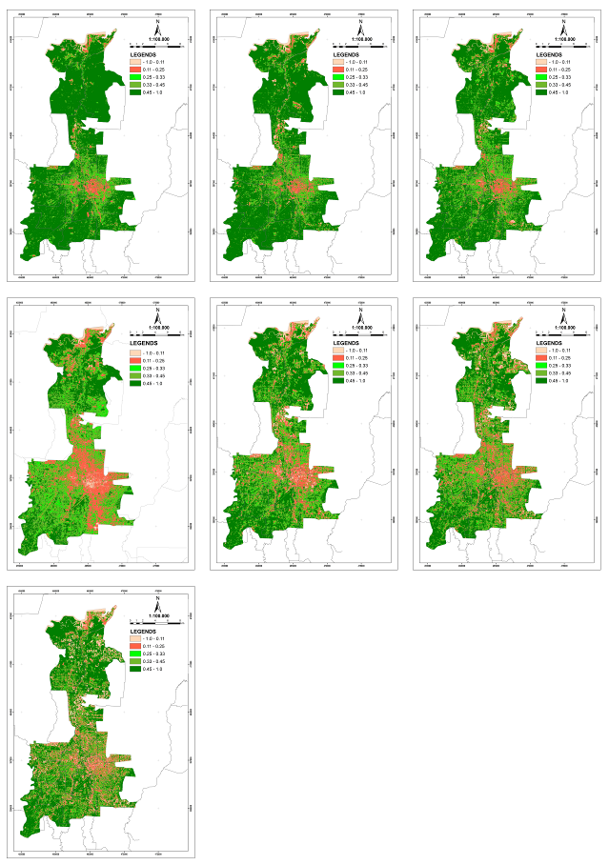
Figure 2. Spatial Distribution in Medan for 1990, 1995, 2000, 2010, 2015, and 2019

Figure 3 shows the graphical presentation of the spatial and temporal change of mean NDVI. The mean of NDVI has decreased over three phases in 1990 indices were 0.59, 1995 was 0.57, and 0.51 in 2000, which was 0.36 in 2005, but the 2010 NDVI average was increasing by 0.42 and slowly decreased in 2015 by 0.41 and in 2019 increase in 0.44. Overall during the period, the vegetation indices in Medan have been detected, indicating an increasing intensity of low-vegetation and non-vegetation.

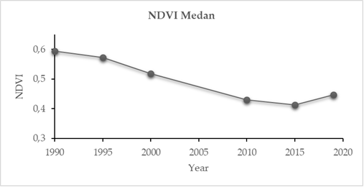
Figure 3. Mean of NDVI Per Year in 1990 until 2019

Distribution and Spatio-temporal of LST
The spatial distribution of LST in Medan is seen in figure 4. In 1990, Medan had a minimum LST at 17 °C, mean LST in 25.32 °C, and 32 °C. The pattern of LST in 1990 was described all-around Medan, in the north area are represents temperature from 19 °C – 22 °C followed by in the middle area was indicated high LST is represented by 22 °C - 25 °C. The high LST was slowly moved from the center (range 22°C - 25°C) spread all over the north in 1995. In the next three phases (2000, 2010, and 2015), the value of the maximum and minimum LST patterns have been upheaved. Most of all area is characterized by the temperature ranges from 22 °C -16 °C. In 2019, a maximum of LST had been raised at 19.08 °C for a minimum and 33.41 °C for maximum and meant at 27 °C of LST. The area of Medan is represented LST from 27 °C – 30 °C, and the core urban area is sensitive to high temperature.

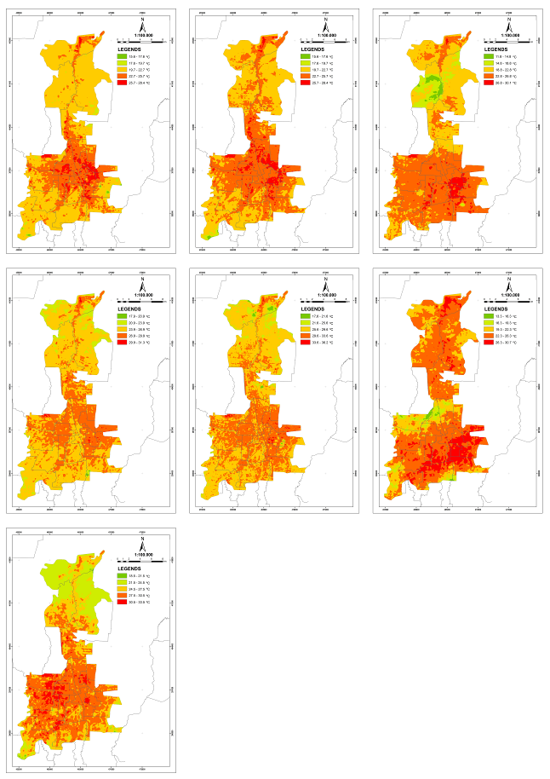
Figure 4. Spatial Distribution of Land Surface Temperature (LST) In Medan From 1990 until 2019

The mean of LST from 1990-2015 has risen from 25.32 °C until 27.18 °C, respectively (see Figure 5). However, in 2019, in 2019, the temperature has decreased in the mean value of 27 °C C. All the period, this growth is entirely has increased, and the annual rate of increase is 0.44 °C /five year. This graph in figure 5 describes the seasonal increase of LST over different phases. It is observed that in all seasons, LST increased, and the rate is considerably dangerous.

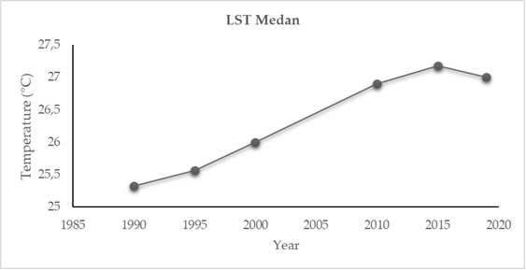
Figure 5. Mean of LST in Medan Per Year For 1990 until 2019

Correlation of LST and NDVI
To find out the correlation between LST and NDVI in this study is using the linear regression method. According to Edwards (1984), the correlation coefficient in regression analysis is a measure of the strength of the linear relationship between the independent variable (X) and the dependent variable (Y). The values of these coefficients range from -1 to +1. A correlation coefficient of -1 indicates a perfect negative correlation, while +1 indicates a perfect positive correlation. The NDVI has been considered to correlate with LST conditions. In figure 6, LST presents a strong negative relationship with NDVI with a correlation coefficient (R2) of 0.98. The regression equation between NDVI and LST obtained was y = -0,0956 x + 3,0122 with LST in Celsius degree as the x variable and NDVI as the y variable. This value indicated a correlation between the NDVI value and the LST value, where increasing the NDVI value, the LST value will tend to decrease.
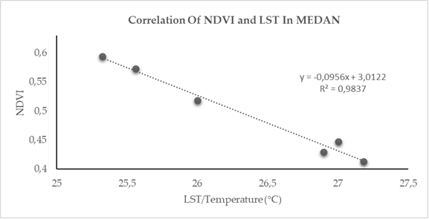
Figure 6. Linier Relation Between mean LST and mean NDVI in Medan from 1990-2019

The Spatio-temporal NDVI and LST in Medan

Distribution and Spatio-temporal on NDVI
Figure 7 presents the spatiotemporal status of NDVI indices for Bandung during the entire period in 1990 until 2019. The average values of maximum NDVI were gradually decreased over the years from 1990 until 2019. NDVI in 1990 had an average of 0.41, 1995 of 0.403, 2000 of 0.40, 2005 of 0.38, 2010 of 0.37, 2015 of 0.32, and 2019 of 0.30. The level of vegetation density changed in 1990 until 2019. NDVI in 1990, the high-density class of dark green vegetation still dominates along the north, east, and southern parts of Bandung (NDVI>0.4), meanwhile in the center part showed low vegetation and non-vegetation index (NDVI<0.25). Over time, in 2019, at first, a very well-vegetated area became a low-vegetation (NDVI<0.25) area by a peach color and non-vegetation areas with a pink color spread evenly throughout the Bandung area.
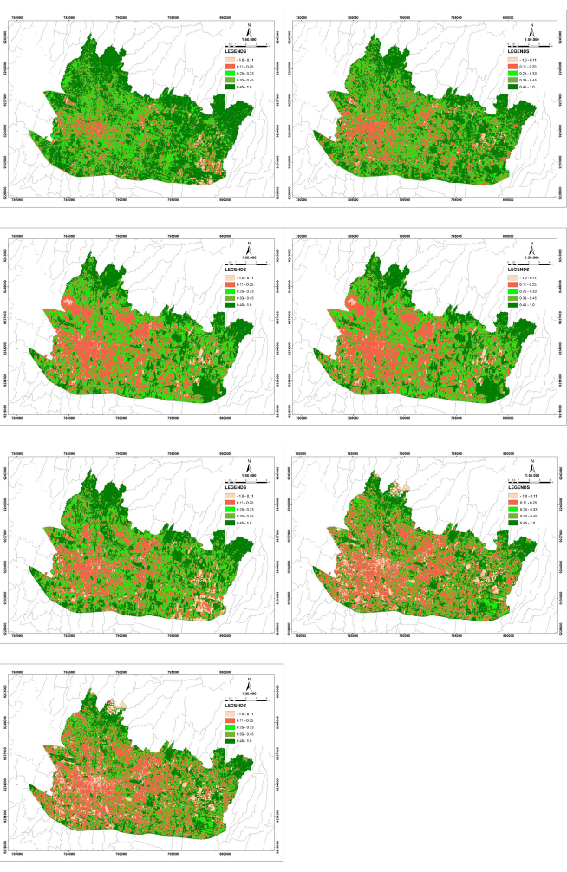
Figure 7. Spatial Distribution of NDVI in Bandung for 1990 until 2019
The mean of NDVI in Figure 8 shows the graphical presentation of the spatial and temporal change of mean NDVI. The average values NDVI per year were gradually decreased, 0.41 in 1990, 0.403 in 1995, 0.40 in 2000, 0.38 in 2005, 0.37 in 2010, and 2015 – 2019, the NDVI indices were drastically decreased in 0.30. Overall during the period, the vegetation indices in Bandung have been detected, indicating an increasing intensity of low-vegetation and non-vegetation.

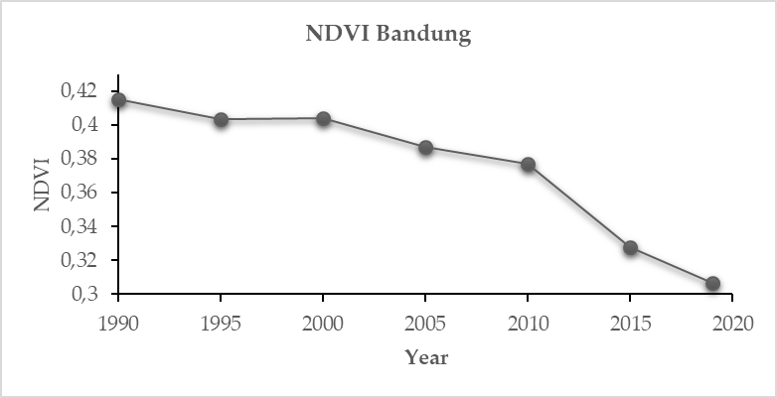
Figure 8. Mean of NDVI in Bandung Per Year For 1990 until 2019

Distribution and Spatio-temporal of LST
Figure 9 describes the variation of the LST of the seven different years. There is a general similarity in the spatial pattern of land surface temperature for the different years where the higher temperature (shown in red color) is mainly located in the central and the western parts of the city from 1990 until 2019. In 1990, the lower temperature represented temperature from 18 °C – 22 °C (described in yellow) in the northwest, the northeast, and the southeast parts of the city. Red color that describes as the higher temperature (around 26 °C) slowly moves forward from the center to the northwest, the northeast, and the southeast parts of the city. The LST in 1995 all area in Bandung was dominated by 21 °C until 26 °C. While in 2000, 2005, and 2010, most of all area is characterized by the temperature ranges from 21°C until 26°C and there was a minimum temperature in northwest and southeast around 17 °C.
Moreover, in 2015-2019 all areas are dominated by 26°C – 29 °C. Although quite different anomalies or land surface temperature patterns began from 1990 to 2019, the results can be used as an illustration to investigate the local characteristics of surface temperature in the study area. Overall, this evidence clearly shows that Bandung's land surface temperature pattern is well identifiable from its geographic location where the higher LST area is in the city center. In contrast, the low-temperature areas occur near the southeastern suburbs. (Simanjuntak 2017).
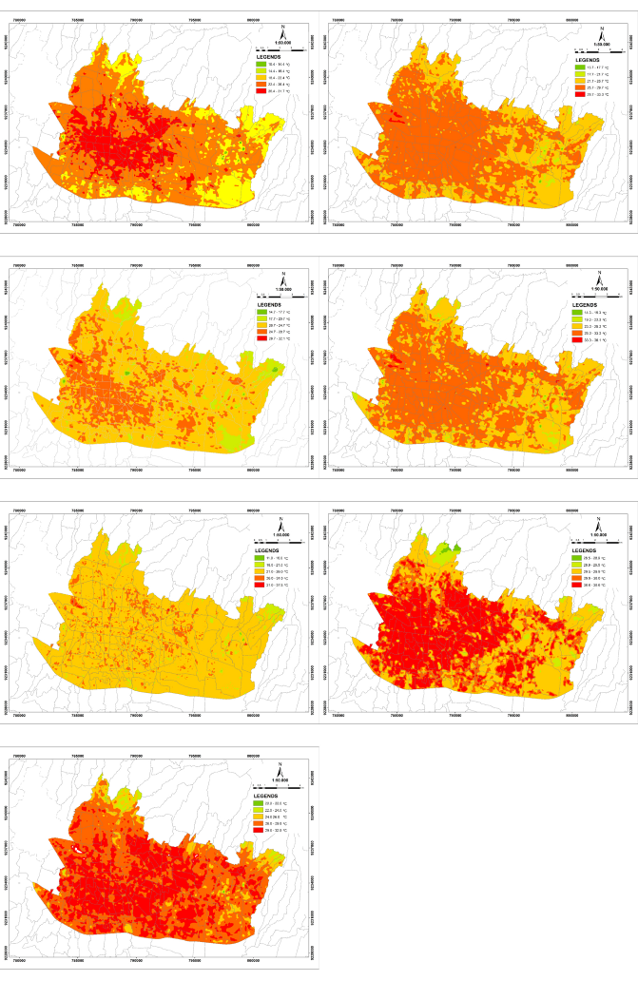
Figure 9. Spatial Distribution of LST In Bandung For 1990 until 2019

In general, the mean temperature values show an increasing trend in several years (Figure 10). Despite the slight decreases in 2000 and more significant decreases in 2019, the overall mean temperature still shows an increasing trend (23.30 °C in 1990, 24.57 °C in 1995, 24.52 °C in 2000, 25.63 °C in 2005, 25.51 °C in 2010, 25.78 °C in 2015, and 27.9 °C in 2019). In this case, the mean LST values are shown in Figure 10 that Bandung became warmer with time, average rising by 1°C every 5 year.
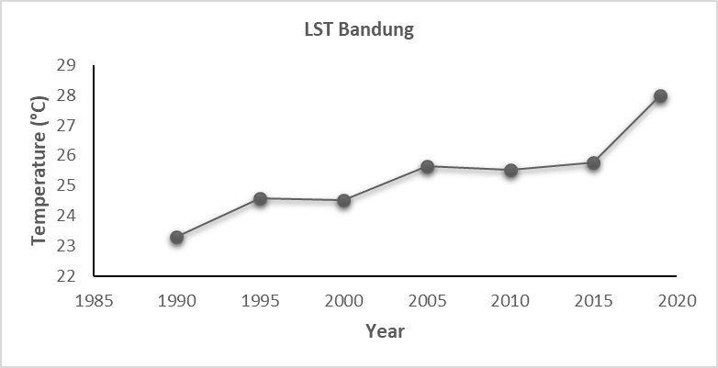
Figure 10. Mean of LST in Bandung Per Year For 1990 until 2019

Correlation of LST and NDVI

Figure 11 shows the linear regression model results, which have a strong correlation (with R² 0.8078) in the observed period of 29 years (1990 to 2019). Furthermore, the results indicate that the LST negatively correlates with the NDVI range of 0.3 - 0.4. In this range, the mean temperature shows a linear decline when the mean NDVI increase.

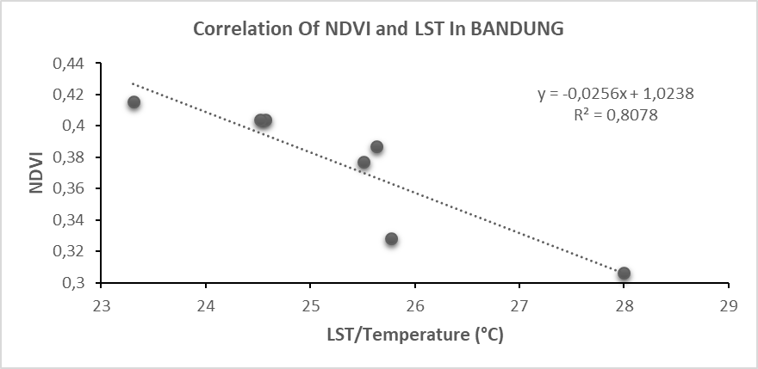
Figure 11. Linier Relation Between mean LST and mean NDVI in Bandung from 1990-2019

The Spatio-temporal NDVI and LST in Makassar

Distribution and Spatio-temporal of NDVI

The spatial distribution in 1995 of NDVI Makassar was dominated by high vegetation indices present in 0.33- 0.45. Vegetation can be found in parts of the city, but most gather in the middle-northeast to the east. In Makassar City, impoverished surface areas were concentrated in the central part of the city, extending diagonally to the southeast. The indices of vegetation are low vegetation and non-vegetation (0.11 until 0.25). The conditions of vegetation in 2000 seems stable. In the next four phases (2005, 2010, 2015, 2019), the indices of NDVI slowly moved from high vegetation become low vegetation, and non-vegetation spread all the area.
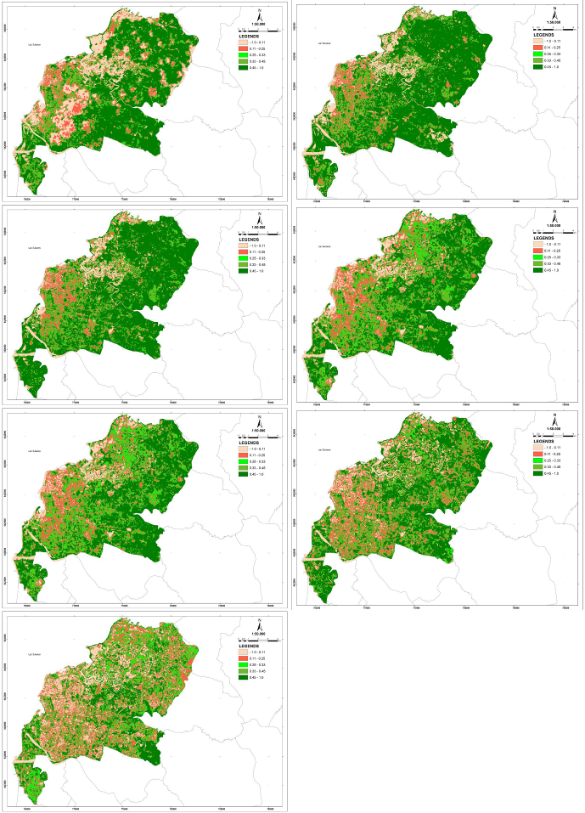
Figure 12. Spatial Distribution of NDVI in Makassar for 1990 until 2019
The graphical presentation of the spatial and temporal change of mean NDVI in Makassar(Figure 13). The average values NDVI per five year were slowly decreased (0.484 in 1995, 0.482 in 2000, 0.43 in 2005, 0.42 in 2010, 0.39 in 2015, and 0.29 in 2019). Overall during the period, the vegetation indices in Makassar have been indicated to decrease to low-vegetation and non-vegetation.
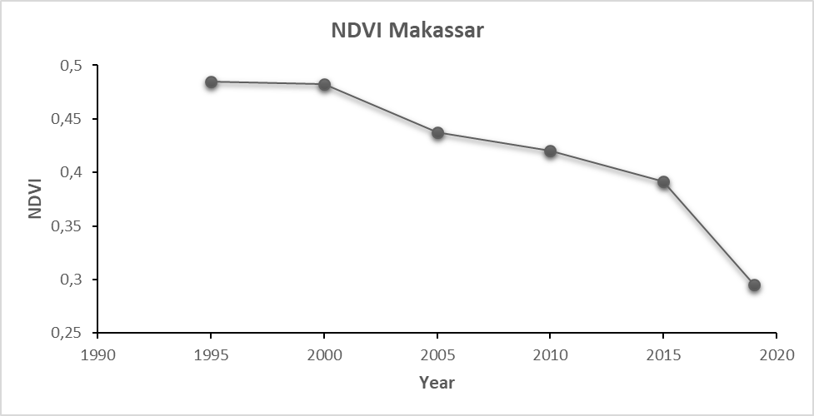
Figure 13. Mean of NDVI in Makassar In 1990 until 2019

Distribution and Spatio-temporal of LST

The LST pattern in Makassar from 1995 until 2019 seems to be spread evenly in most areas (Figure 14). In 1995, a part of northwest dominated LST in 19.8 °C – 20 °C, and the center area the LST was around 22 °C. In 2010 a part of the northwest became higher in the range 24 °C – 27 °C. Nevertheless, in 2015 and 2019, the LST increased gradually in the northwest and the southeast, dominated by 29.6 °C – 29.9 °C. The higher values of LST are observed in the middle of the northwest around 30 °C.
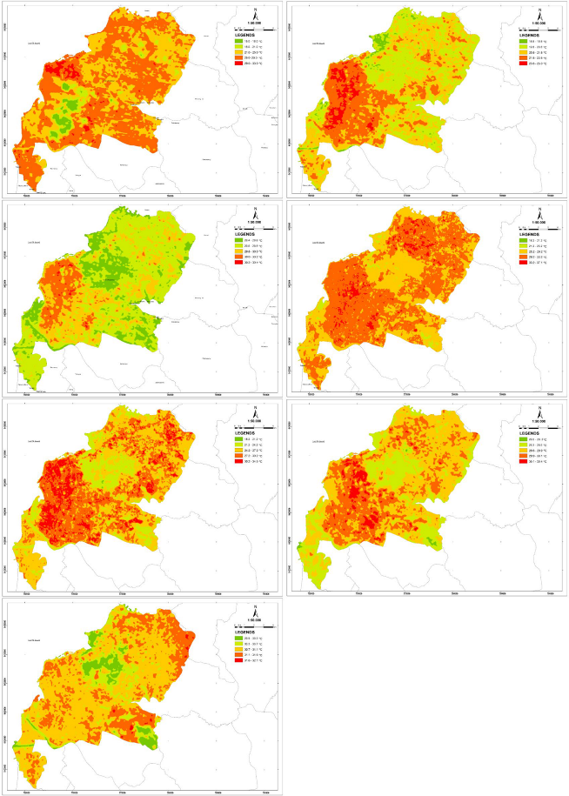
Figure 14. Spatial Distribution of LST In Makassar For 1990 until 2019

Figure 15 shows that the average annual mean LST value lies between 28.34°C (1995) and 30.91°C (2019). The distribution of Spatio-temporal LST in Makassar seems slowly increase by around 0.07 °C per five years.

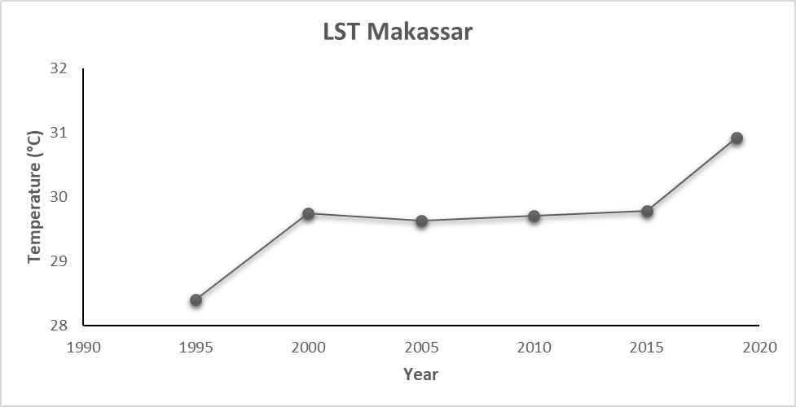
Figure 15. Mean of LST in Bandung in 1990 until 2019

Correlation of LST and NDVI

Correlation analysis carried on the NDVI value and the LST value of Makassar produced a correlation value of R² = 0.7094 with the linear equation y = -0.0748x + 2.642. This value shows a correlation between the NDVI value and the LST value, which has a strong negative relationship, where increasing the NDVI value, then the LST value will tend to decrease.

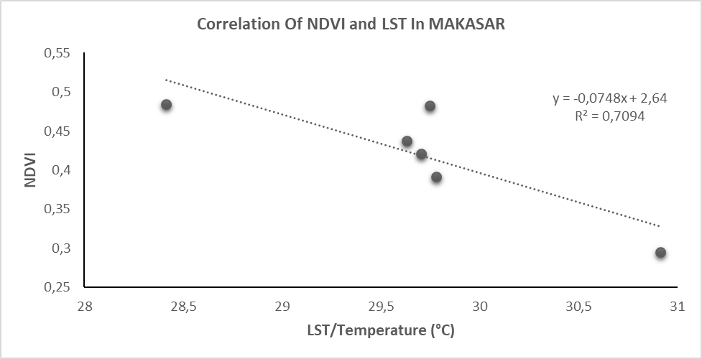
Figure 16. Linier Relation Between mean LST and mean NDVI in Makassar from 1990-2019

Comparisson of spatio-temporal characteristic of NDVI and LST in Medan, Bandung, and Makassar.
The relationship between NDVI and LST in Medan, Bandung, and Makassar has a strong negative relationship. This value indicated a correlation between the NDVI value and the LST value, where increasing the NDVI value, the LST value will tend to decrease.

Table 2. The Average of LST and NDVI From 1990 until 2019 in three cities
 | LST Average (°C) | NDVI Average
Medan | 26 | 0.49
Bandung | 25 | 0.37
Makassar | 29 | 0.41

Compared with three cities, Bandung has the lowest indices of vegetation (0.37) and the lowest LST (25 °C), while Makassar has the highest LST at 29 °C. However, the indices of NDVI are 0.41 indicated that the density of vegetation is moderate. Each city distributing the Spatio-temporal of NDVI each city from 1990 until 2019 shows Bandung has the rapid change from high vegetation indices to low vegetation or non-vegetation every five years. Furthermore, LST's Spatio-temporal increased every five years for average 0.44 °C in Medan, 1°C in Bandung, and 0.07 °C in Makassar.
So, in this study, Bandung is the most rapid increase in LST and decreased in NDVI. It probably because of a very drastic urban growth in Bandung than in Medan and Makassar. According to Simanjuntak (2017)(Simanjuntak 2017) in other sources of different LST every year can be from human activities, e.g., energy consumption from buildings and transportation can also be influenced by the LST effect. However, the most important factors to be considered are LST continuation, where each location consists of different types of buildings, vegetation, and other types [17]. Besides that, more vegetation cover (greater NDVI) in some land-use/cover areas can cause correspondingly higher evapotranspiration rates and promote the latent and sensible heat exchange between the land surface and atmosphere compared with limited vegetation cover, such as in moreover developed areas (Yue et al. 2014).

Conclussion
The study results indicate that the distribution and Spatio-temporal of NDVI and LST in Medan, Bandung, and Makassar over the 29 years have a drastic increase for NDVI and decreased LST for each city. The Correlation of NDVI and LST in Medan, Bandung, and Makassar can be concluded that LST is related closely to the land surface's characteristics. The excess of vegetation and LST have a significant inverse correlation.

References
Carlson, Toby N., and David A. Ripley. 1997. “On the Relation between NDVI, Fractional Vegetation Cover, and Leaf Area Index.” Remote Sensing of Environment 62 (3): 241–52. https://doi.org/10.1016/S0034-4257(97)00104-1.
Fathizad, Hassan, Mahdi Tazeh, Saeideh Kalantari, and Saeed Shojaei. 2017. “The Investigation of Spatiotemporal Variations of Land Surface Temperature Based on Land Use Changes Using NDVI in Southwest of Iran.” Journal of African Earth Sciences 134: 249–56. https://doi.org/10.1016/j.jafrearsci.2017.06.007.
Guha, Subhanil, and Himanshu Govil. 2020. “An Assessment on the Relationship between Land Surface Temperature and Normalized Difference Vegetation Index.” Environment, Development and Sustainability, no. 0123456789. https://doi.org/10.1007/s10668-020-00657-6.
Guha, Subhanil, Himanshu Govil, and Prabhat Diwan. 2020. “Monitoring LST-NDVI Relationship Using Premonsoon Landsat Datasets.” Advances in Meteorology 2020 (1). https://doi.org/10.1155/2020/4539684.
Hernawati, Rika, and Soni Darmawan. 2018. “Change Detection Analysis Using NDVI in Bandung, Indonesia.” Proceedings - 39th Asian Conference on Remote Sensing: Remote Sensing Enabling Prosperity, ACRS 2018 2 (October 2018): 1203–10.
Hope, A. S., and T. P. McDowell. 1992. “The Relationship between Surface Temperature and a Spectral Vegetation Index of a Tallgrass Prairie: Effects of Burning and Other Landscape Controls.” International Journal of Remote Sensing 13 (15): 2849–63. https://doi.org/10.1080/01431169208904086.
Islam, Shahidul, and Mingguo Ma. 2018. “Geospatial Monitoring of Land Surface Temperature Effects on Vegetation Dynamics in the Southeastern Region of Bangladesh from 2001 to 2016.” ISPRS International Journal of Geo-Information 7 (12). https://doi.org/10.3390/ijgi7120486.
Kim, Hyung-Moo, Beob-Kyun Kim, and Kang-Soo You. 2005. “A Statistic Correlation Analysis Algorithm Between Land Surface Temperature and Vegetation Index.” Journal of Information Processing Systems. https://doi.org/10.3745/jips.2005.1.1.102.
Kumar, Deepak, and Sulochana Shekhar. 2015. “Statistical Analysis of Land Surface Temperature-Vegetation Indexes Relationship through Thermal Remote Sensing.” Ecotoxicology and Environmental Safety 121 (2): 39–44. https://doi.org/10.1016/j.ecoenv.2015.07.004.
“Landsat 8 (L8) Data Users Handbook.” 2019.
Mukherjee, Falguni, and Deepika Singh. 2020. “Assessing Land Use–Land Cover Change and Its Impact on Land Surface Temperature Using LANDSAT Data: A Comparison of Two Urban Areas in India.” Earth Systems and Environment 4 (2): 385–407. https://doi.org/10.1007/s41748-020-00155-9.
Muzaky, H., and L. M. Jaelani. 2019. “Analysis of the Impact of Land Cover on Surface Temperature Distribution: Urban Heat Island Studies I}n Medan and Makassar.” IOP Conference Series: Earth and Environmental Science 389 (1). https://doi.org/10.1088/1755-1315/389/1/012047.
Ningrum, Widya, and Ida Narulita. 2018. “Deteksi Perubahan Suhu Permukaan Menggunakan Data Satelit Landsat Multi-Waktu Studi Kasus Cekungan Bandung.” Jurnal Teknologi Lingkungan 19 (2): 145. https://doi.org/10.29122/jtl.v19i2.2250.
OS, Babalola, and Akinsanola AA. 2016. “Change Detection in Land Surface Temperature and Land Use Land Cover over Lagos Metropolis, Nigeria.” Journal of Remote Sensing & GIS 5 (3). https://doi.org/10.4172/2469-4134.1000171.
Pal, Swades, and Sk Ziaul. 2017. “Detection of Land Use and Land Cover Change and Land Surface Temperature in English Bazar Urban Centre.” Egyptian Journal of Remote Sensing and Space Science 20 (1): 125–45. https://doi.org/10.1016/j.ejrs.2016.11.003.
Qin, Z., A. Karnieli, and P. Berliner. 2001. “A Mono-Window Algorithm for Retrieving Land Surface Temperature from Landsat TM Data and Its Application to the Israel-Egypt Border Region.” International Journal of Remote Sensing 22 (18): 3719–46. https://doi.org/10.1080/01431160010006971.
Rahmad, Riki, Ali Nurman, and Kamarlin Pinem. 2019. “Impact Of NDVI Change To Spatial Distribution Of Land Surface Temperature (A Study in Medan City, Indonesia)” 208 (Icssis 2018): 167–71. https://doi.org/10.2991/icssis-18.2019.33.
S., Anbazhagan, and Paramasivam C.R. 2016. “Statistical Correlation between Land Surface Temperature (LST) and Vegetation Index (NDVI) Using Multi-Temporal Landsat TM Data.” International Journal of Advanced Earth Science and Engineering 5 (1): 333–46. https://doi.org/10.23953/cloud.ijaese.204.
Sari, Dewi Kania, Gun Gun, and Gunawan Hudman. 2005. “Map Asia 2005 Jakarta , Indonesia STUDY ON VEGETATION COVER CHANGES IN THE PROVINCE OF SOUTH KALIMANTAN USING RGB-NDVI UNSUPERVISED CLASSIFICATION METHOD © Map Asia Conference 2005 Map Asia 2005 Jakarta , Indonesia © Map Asia Conference 2005,” 1–9.
Simanjuntak, Royger Maniur. 2017. “Analyzing The Relationship Between Land Surface Temperature And Urban Structure Types In Bandung , Indonesia,” 121.
Smith, R. C., and B. J. Choudhury. 1990. “On the Correlation of Indices of Vegetation and Surface Temperature over South-Eastern Australia.” International Journal of Remote Sensing 11 (11): 2113–20. https://doi.org/10.1080/01431169008955164.
Tariq, Aqil, Iqra Riaz, Zulfiqar Ahmad, Bisheng Yang, Muhammad Amin, Rukhsana Kausar, Shaista Andleeb, Muhammad Aslam Farooqi, and Muhammad Rafiq. 2020. “Land Surface Temperature Relation with Normalized Satellite Indices for the Estimation of Spatio-Temporal Trends in Temperature among Various Land Use Land Cover Classes of an Arid Potohar Region Using Landsat Data.” Environmental Earth Sciences 79 (1): 1–15. https://doi.org/10.1007/s12665-019-8766-2.
Tucker, Compton J. 1979. “Red and Photographic Infrared Linear Combinations for Monitoring Vegetation.” Remote Sensing of Environment 8 (2): 127–50. https://doi.org/10.1016/0034-4257(79)90013-0.
Wardana, Inu Kusuma. 2015. “Analysis of Urban Surface Temperature for Green Spaces Planning in Bandung City , Indonesia.” Msc. Thesis, no. 1: 593–605.
Weng, Qihao, Dengsheng Lu, and Jacquelyn Schubring. 2004. “Estimation of Land Surface Temperature-Vegetation Abundance Relationship for Urban Heat Island Studies.” Remote Sensing of Environment 89 (4): 467–83. https://doi.org/10.1016/j.rse.2003.11.005.
Yue, W., J. Xu, W. Tan, and L. Xu. 2007. “The Relationship between Land Surface Temperature and NDVI with Remote Sensing: Application to Shanghai Landsat 7 ETM+ Data.” International Journal of Remote Sensing 28 (15): 3205–26. https://doi.org/10.1080/01431160500306906.
Yue, W, J Xu, W Tan, and L Xu. 2014. “The Relationship between Land Surface Temperature and NDVI with Remote Sensing : Application to Shanghai Landsat 7 ETM + Data The Relationship between Land Surface Temperature and NDVI With,” no. May. https://doi.org/10.1080/01431160500306906.

